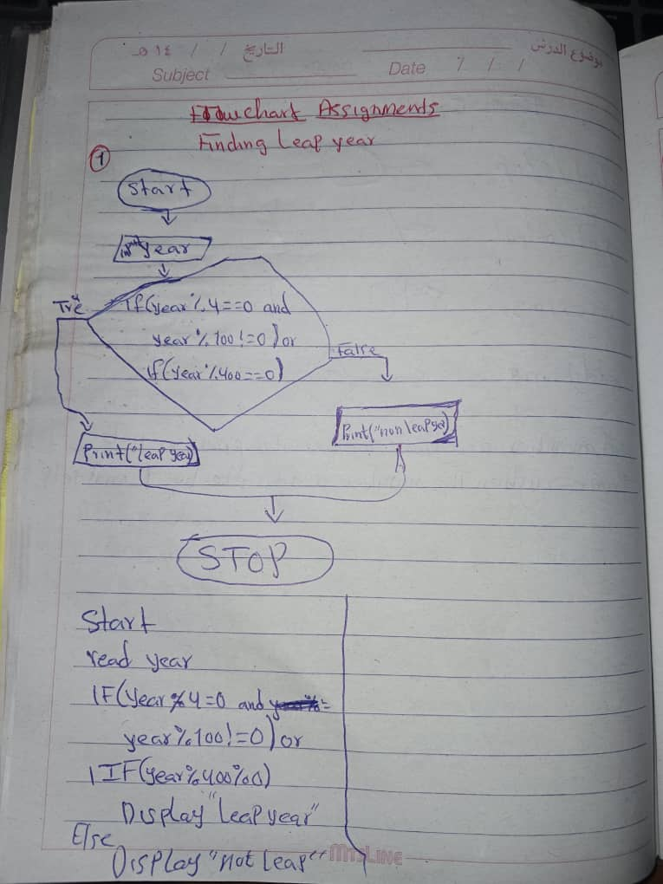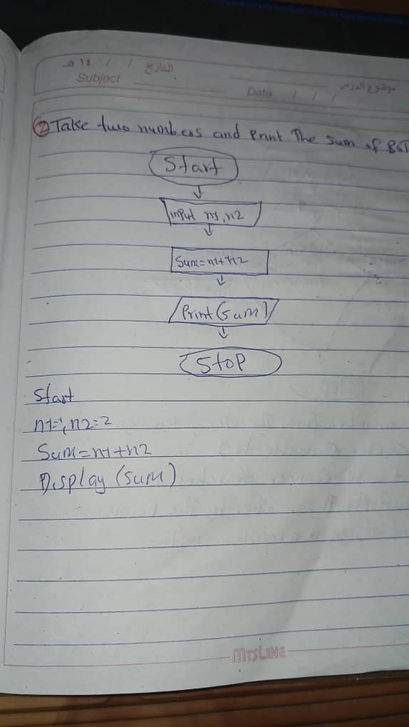

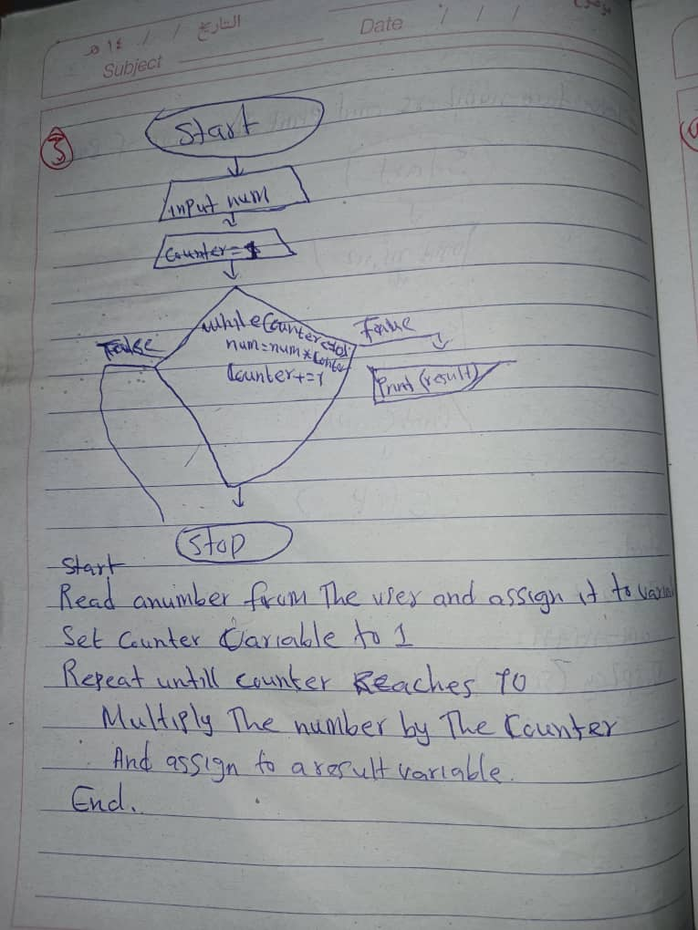

**02 First-java.md**

**Solutions**

1. Write a program to print whether a number is even or odd, also take input from the user.

Scanner sc = new Scanner(System.in);

Int num = sc.nextInt();

if(num%2=0)

{

System.out.println(“even”);

}

else{

System.out.println(“odd”);

}

1. Take name as input and print a greeting message for that particular name.

Scanner sc = new Scanner(System.in);

String name = sc.nextLine();;

System.out.println(“Hi ”+name);

1. Write a program to input principal, time, and rate (P, T, R) from the user and find Simple Interest.

Scanner sc = new Scanner(System.in);

System.out.println(“Enter principal”);

Int principal = sc.nextInt();

System.out.println(“Enter time”);

Int time = sc.nextInt();

System.out.println(“Enter rate”);

Int rate = sc.nextInt();

Interest = principal * time * rate;

System.out.println(interest);

1. Take in two numbers and an operator (+, -, *, /) and calculate the value. (Use if conditions)

Scanner sc = new Scanner(System.*in*);

System.*out*.println("Enter num1");

int num1 = sc.nextInt();

System.*out*.println("Enter num2");

int num2 = sc.nextInt();

System.*out*.println("Enter an operator");

String op = sc.nextLine();

String operator = sc.nextLine();

if ( operator.equals("+"))

{

int sum = num1 + num2;

System.*out*.println(sum);

}

else if(operator.equals("-"))

{

int sub = num1 - num2;

System.*out*.println(sub);

}

else if(operator.equals("*"))

{

int mul = num1 * num2;

System.*out*.println(mul);

}

else if(operator.equals("/"))

{

int div = num1 / num2;

System.*out*.println(div);

}

1. Take 2 numbers as input and print the largest number.

Scanner sc = new Scanner(System.*in*);

System.*out*.println("Enter num1");

int num1 = sc.nextInt();

System.*out*.println("Enter num2");

int num2 = sc.nextInt();

if(num1 > num2)

{

System.out.println(num1);

}

else if(num2 > num1) {

System.out.println(num2);

}

else:

{

System.out.println(“They are equal”);)

}

1. Input currency in rupees and output in USD.

Scanner sc = new Scanner(System.*in*);

System.*out*.println("Enter Rupees currency to convert usd");

float curRupees = sc.nextInt();

double curUSD = curRupees / 75.0;

System.*out*.println(curUSD+"$");

7. To calculate Fibonacci Series up to n numbers.

8. To find out whether the given String is Palindrome or not.

9. To find Armstrong Number between two given number.